**IACSD**



**INSTITUTE FOR ADVANCED**

**COMPUTING AND**

**SOFTWARE DEVELOPMENT**

**AKURDI, PUNE**

**Documentation On**

“ONLINE STUDENT MANAGEMENT SYSTEM”

**PG-DAC SEPT 2021**

**Submitted By:**

Group No: 81

219127-Pavankumar Biradar

219137-Ragini Pandey

**Prashant Karhale Mr. MilindArjun**

**Centre Coordinator Project Guide**

**Table of Contents**

**1. Introduction............................................................................................5**

1.1. Document Purpose…………………………………………5

1.2 Product Scope………………………………………………5

1.3 Definitions…………………………………………………5

1.4 Overview…………………………………………………...6

-Existing System

-Need for New System

**2. Overall Description……………………………………………............**7

2.1 Product Perspective……………………………………7

2.2 Product Functions………………………………………7

2.3 User Characteristics…………………………………….10

2.4 Principle Actors…………………………………………10

2.5 General Constraints……………………………………..11

2.6 Assumptions&Depenencies……………………………..11

**3. Specific Requirements…………………………………………….......**11

3.1 Functional Requirements……………………………………11

3.2 Non-functional Requirements……………………………….12

3.3 Performance Requirements………………………………….14

3.4 Technical Issues……………………………………………..15

-Software and Hardware Requirements

**4. System Design Specification…………………………………………**16

4.1 System flow chart……………………………………16

4.2 ER Diagram………………………………………….19

4.3 Activity Diagram…………………………………….21

4.4 Sequence Diagram…………………………………..24

4.5 Class Diagram………………………………………27

4.6 Data flow Diagram……………………………………..28

**5. Database Design……………………………………………............**29

5.1 Table Structure……………………………………30

- admin_tbl

- attendance_tbl

- batch_tbl

- course_tbl

-feedback_tbl

-mark_tbl

-students_tbl

- subject_tbl

- teachers_tbl

**6. Conclusion……………………………………………............**40

6.1 Future Scope……………………………………41

**7. References……………………………………………............**41

**List of Figures**

Figure 1; Use case diagram for Admin…………………………..08

Figure 2: Use case diagram for Teacher………………………….09

Figure 3: Use case diagram for Student………………………….10

Figure 4: ER diagram……………………………………………..20

Figure 5: Activity diagram for Admin……………………………21

Figure 6: Activity diagram for Teacher…………………………..22

Figure 7: Activity diagram for Student…………………………..23

Figure 8 : Sequence diagram for Admin…………………………24

Figure 9: Sequence diagram for Teacher………………………...25

Figure 10: Sequence diagram for Student……………………….26

Figure 11: Class Diagram………………………………………..27

Figure 12: Level Zero DFD……………………………..............28

Figure 13: Level One DFD………………………………………28

Figure 14: Level two DFD……………………………………….29

# Introduction

### 1.1 Document Purpose:

This document is meant to focus the features of Online Portal for Student Management System for a CDAC Institute so as to serve as a guide to the developers on one hand and software validation document .

It is a system designed especially for a CDAC Institute. This system provides complete functionality of student and Teacher login where students can access the marks, attendance and submission related work

### 1.2 Product Scope:

This system will be the best medium between the College Management and the Students in all aspects to achieve one to one connection with students.

### 1.3 Definitions:

SRS- Software Requirement Specification

GUI- Graphical User Interface

OSMS- Online Student Management System

**1.4 Overview:**

It is a system designed especially for a CDAC Institute. This system provides complete functionality of student and Teacher login where students can access the marks,attendance and submission related work.

This System is proposed for the three level modules

1.Admin (The Adminstrator of whole System)

2.Teacher(Having their own Functionalities )

3.Students(Can access the data which is provided for them)

**EXISTING SYSTEM**

* An existing system for the Institute is all Scattered one.
* Students have no access to the attendance on daily basis as well as

Module wise.

* College uses the third party app for Assignment Submission
* Students have no access to their Internal Marks in the Existing System.

**NEED FOR NEW SYSTEM**

* The new system is totally computerized system.
* A new system provides features like student login and can track his/her attendance record
* Students can submit the assignments on this portal only such that respective teacher can access it .
* Students get to know the internal as well as End module marks as well as remarks provided by teachers.
* Students can give the feedback whenever they think .
* College management need not to worry about the student data as they can access each and everything about any student from any course from this system

**2.Overall Description**:

This Student Management System will act as a mediator between the management and Students where student can access everything they need to and viceversa. Students will have their own portal where they can interact with the college management System talking about both teaching as well as non Teaching .

Admin can control all the activities on this portal teachers can perform their respective functionalities and at the end students are the one for whom this all is for.

**2.1 Product Perspective**:

This product aimed toward students who can access their own as well as provided data for them and college can fulfill having its own student portal ,no need of scattered existing system.

**2.2 Product Functions**:

Online Student Management System should support this use case:

**Use Case Diagrams** : A Use case is a description of set of sequence of actions. Graphically it is rendered as an ellipse with solid line including only its name. Use case diagram is a behavioral diagram that shows a set of use cases and actors and their relationship. It is an association between the use cases and actors. An actor represents a real-world object. Primary Actor - Sender, Secondary- Actor Receiver.

**Use case diagram for admin**

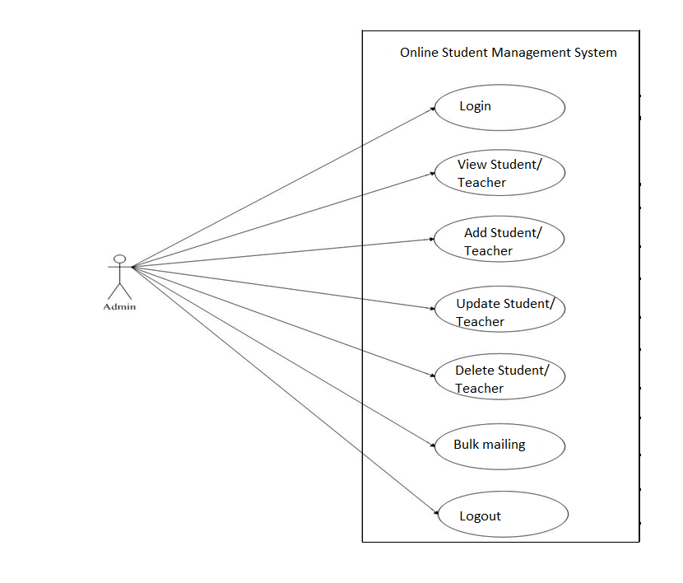

Figure 1:UseCase Diagram for Admin

**Use Case diagram for Users**

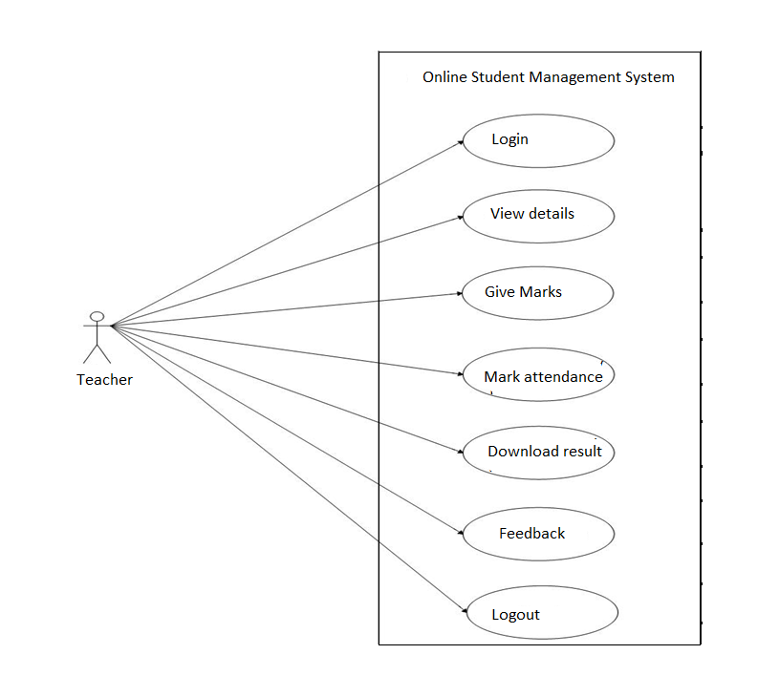

Figure 2:UseCase diag for Teacher

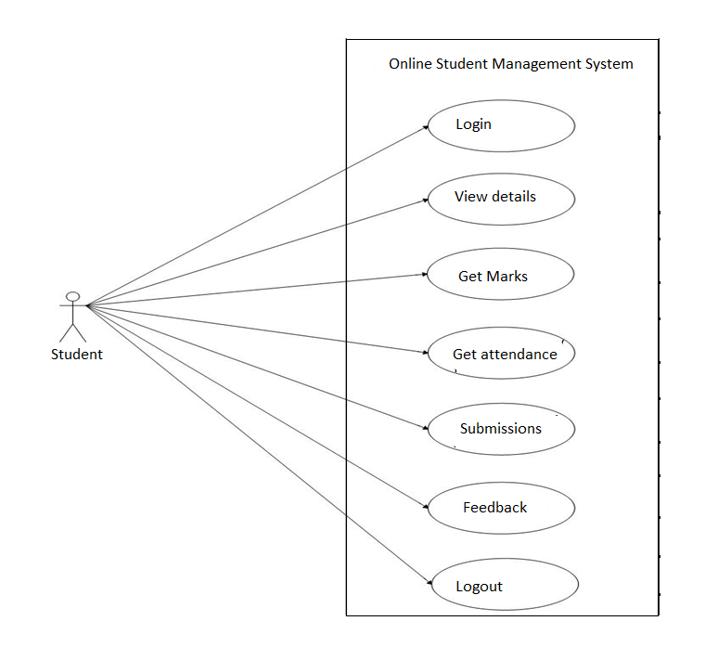

Figure 3:UseCase Diag for Student

**2.3 User Characeristics**:

Teacher and Student these are the two Users of this System

**2.4 Principle Actors**:

2 Principle Actors are Admin and Teacher.

**2.5 General Constraints**:

A full internet connection is required for CRS.

**2.6 Assumptions and Dependencies**:

Working of CRS need Internet Connection.

**3. Specific Requirements**:

**3.1Functional Requirements:**

This System focuses on the Student as the final User and every thing is designed in this system by considering Student at the center Point.

**Admin-**Admin can administrate the whole System,admin can access this system using login id and password after registering through registration form,after login admin can have different functionalities such as adding Particular teacher as he/she joins the organisation and assign the role as such as lab faculty or teaching faculty,and provides the login credentials such as id and password,using that teacher can access the system and student are also added to the system by admin and provide id and password .admin can remove particular teacher if teacher leaves the organisation and same for students .admin is going to post the weekly timetable and the notice if there any.

**Teacher-**Teacher have their role as per the role they have their respective functionalities teaching faculty can post the daily data as well as assignments for students and can have access to the weekly timetable ,notice for them posted by Admin.if teacher is a lab faculty they can give marks to the students for assignments submitted on portal by students as well for end module ,mark the attendance of student modulewise in terms of percentage.

**Student-**Student is the end user of our system who can have access to all the data provided for them as well student can update in the profile if there any changes and can submit assignments on this portal,can acess to the marks and attendance .Students can give feedback trough this portal as well.

College can access the total data of their Students from this System

**3.2 NonFunctional Requirement:**

**Security**

Registered Admin will allowed to access the administration of System

Each User will be to access system through authentication process. Who are you ?

System will provide access to the content , operations using Role based security (Authorization) (Permissions based on Role)

System will automatically log of user after some time due to inactiveness (if Session is timed Out)

System will internally maintain secure communiction channel between Servers ( Web Servers, App Servers, databse Server)

Sensitive data will be always encrypted across communcation.

**Reliability**

The system will backup business data on regular basis and recover in short time duration to keep system operational

Continous updates are matained , continous Adminstration is done to keep system operational.

During the traffic system will maintain same user experaince by managing load balancing .

**Availability**

24* 7 available as user can acess the portal at any time as per its requirement

**Maintainability:**

Commercial database software will be used to maintain System data Persistence.

IT operations team will easily monitor and configure System using Adminstrative tools provided by Servers.

Separate enviornment will be maintained for system for isolation in production, testing, and development.

**Portablility:**

PDA: Portable Device Application

System will provide portable User Interface ( HTML, CSS, JS) through users will be able to access online portal.

System can be deployed to single server, multi server, to any OS, Cloud (Azure or AWS or GCP)

**Accessibility:**

only added user will be able to acess the system.

Admin can add or remove the users.

management team will be able to view the system through admin login.

**Durability:**

System is going to be the best medium between College Authority and the Students.

**Efficiency:**

At the time of high traffic on the System,System will remain as efficient as favourable conditions

**Modularity:**

System will designed and developed for the basically three modules Admin as the principal actor,teacher as a first user and Student as end User.

These modules are Interlinked together in this System

**Scalability:**

System will be able to provide consistent user exeprience to college management as well as Users irrespective of load.

**Safety:**

online portal functionalilites are protected from outside with proper firewall configuration.as anyone could not interfere in others functionalities

online portal will be always kept updated with latest anit virus software.

Data will be backed up periodically to ensure safty of data using increamental back up strategy.

**3.3 Performance Requirements**:

In order to maintain an acceptable speed at maximum number of uploads allowed from a particular customer as any number of users can access to the system at any time. Also the connections to the servers will be based on the attributes of the user like his location and server will be working 24X7 times.

**3.4 Technical Issues**:

This system will work on client-server architecture. It will require an internet server and which will be able to run PHP application. The system should support some commonly used browser such as IE,mozzila firefox,chrome etc.

**HARDWARE REQUIREMENT**

Hardware requirements for insurance on internet

will be same for both parties which are as follows:

|  |  |
| --- | --- |
| **RAM** | 2 GB |
| **Hard disk** | 320 GB |
| **Processor** | Dual Core |

**Software Requirements**

**Client side:**

|  |  |
| --- | --- |
| **Web Browser** | Google Chrome or any  compatible browser |
| **Operating System** | Windows or any equivalent OS |

**Server side:**

|  |  |
| --- | --- |
| **Web Server** | TOMCAT |
| **Server side Language** | JAVA(SpringBoot ) |
| **Database Server** | MYSQL |
| **Web Browser** | Google Chrome or any  compatible browser |
| **Operating System** | Windows or any equivalent OS |

**4.System Design Specification:**

**4.1 System Flow Chart**

**1.Admin**

**star**

Start

Update all Information

Update all Information

Update all Information

Yes

Add Teacher

Add Student

Add Admin

Admin

Yes

Yes

No

Admin

Registration

Is Admin?

Is Valid?

Login

If registered?

Logout

**2.Teacher**

**star**

Start

Added by Admin?

Logout

Stop

Yes

Access for teachers

View Student

Yes

Is Valid?

Teacher

Login

Yes

Can have acess to feedback,weekly timetable posted by admin

Can post daily67 assignments

Lab faculty functionality

Can give marks for Assignment,End Module and Mark the attendence

Can Track all the details of student

Is Teacher?

Teacher

**3.Student**

**star**

Start

Logout

Stop

Yes

Yes

Is Valid?

Login

If Added?

Student

Update Information

Track growth rate

Submit Assignment

Feedback

Modulewise Attendence

Assignment Marks

Remarks by teacher

Timetable

Can Post

Access

View own Details

**4.2 ER DIAGRAM**

The Entity-Relationship (ER) model was originally proposed by Peter in 1976 [Chen76] as a way to unify the network and relational database views. Simply stated the ER model is a conceptual data model that views the real world as entities and relationships. A basic component of the model is the Entity-Relationship diagram which is used to visually represent data objects. Since Chen wrote his paper the model has been extended and today it is commonly used for database design for the database designer, the utility of the ER model is:

* It maps well to the relational model. The constructs used in the ER model can easily be transformed into relational tables.
* It is simple and easy to understand with a minimum of training. Therefore, the model can be used by the database designer to communicate the design to the end user.
* In addition, the model can be used as a design plan by the database developer to implement a data model in specific database management software.

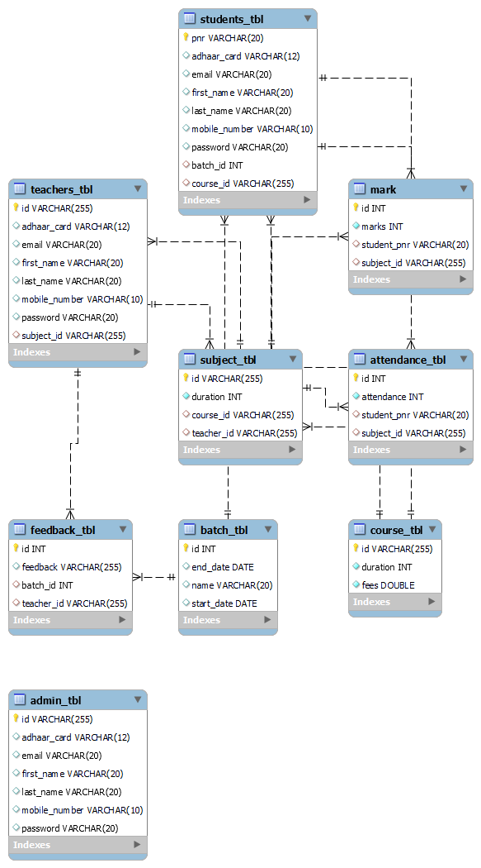

Figure 4 ER diagram

**4.3 Activity diagrams**

**Activity Diagram for admin**

Registration

Login

No

Valid

Yes

Post Notice

View Feedback

Add Admin

Post Timetable

Add Teacher

View everyOne

Add Student

Logout

Figure 5:Activity Diagram for Admin

**Activity Diagram for Teacher**

Login

No

Valid

Yes

Search Student

Mark attend

View Feedback

View Student

Remarks to student

Post Assignment

Logout

Figure 6: Activity diagram for Teacher

**Activity Diagram for Student**

Login

No

Valid

Yes

View prof

View attend

give Feedback

Update prof

Submit assignment

View remarks

Logout

Figure 7: Activity diagram for Student

**4.4 Sequence Diagram Figure 8: for admin**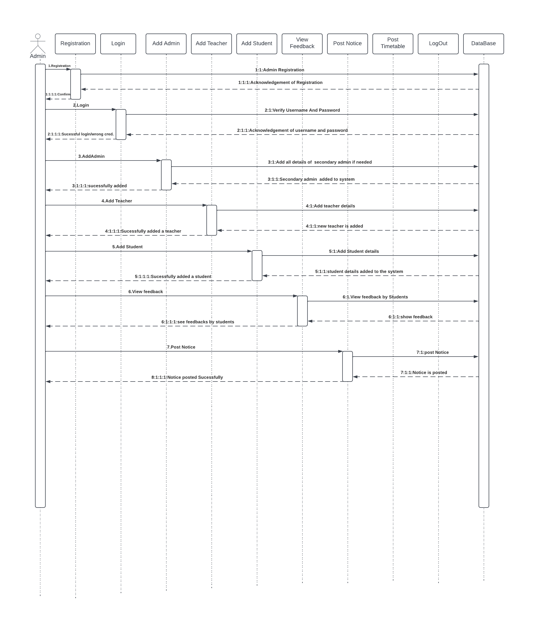

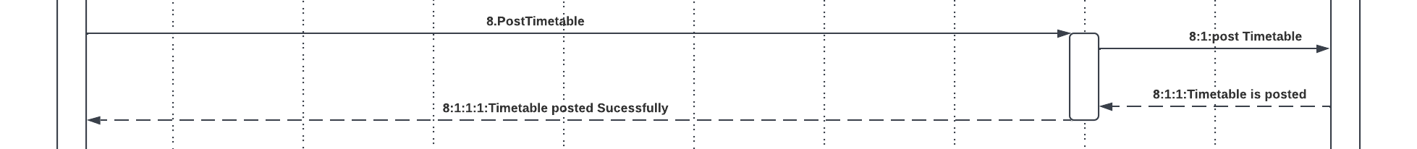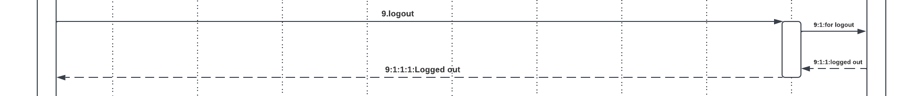

**Figure 9: Sequence Diagram for Teacher**

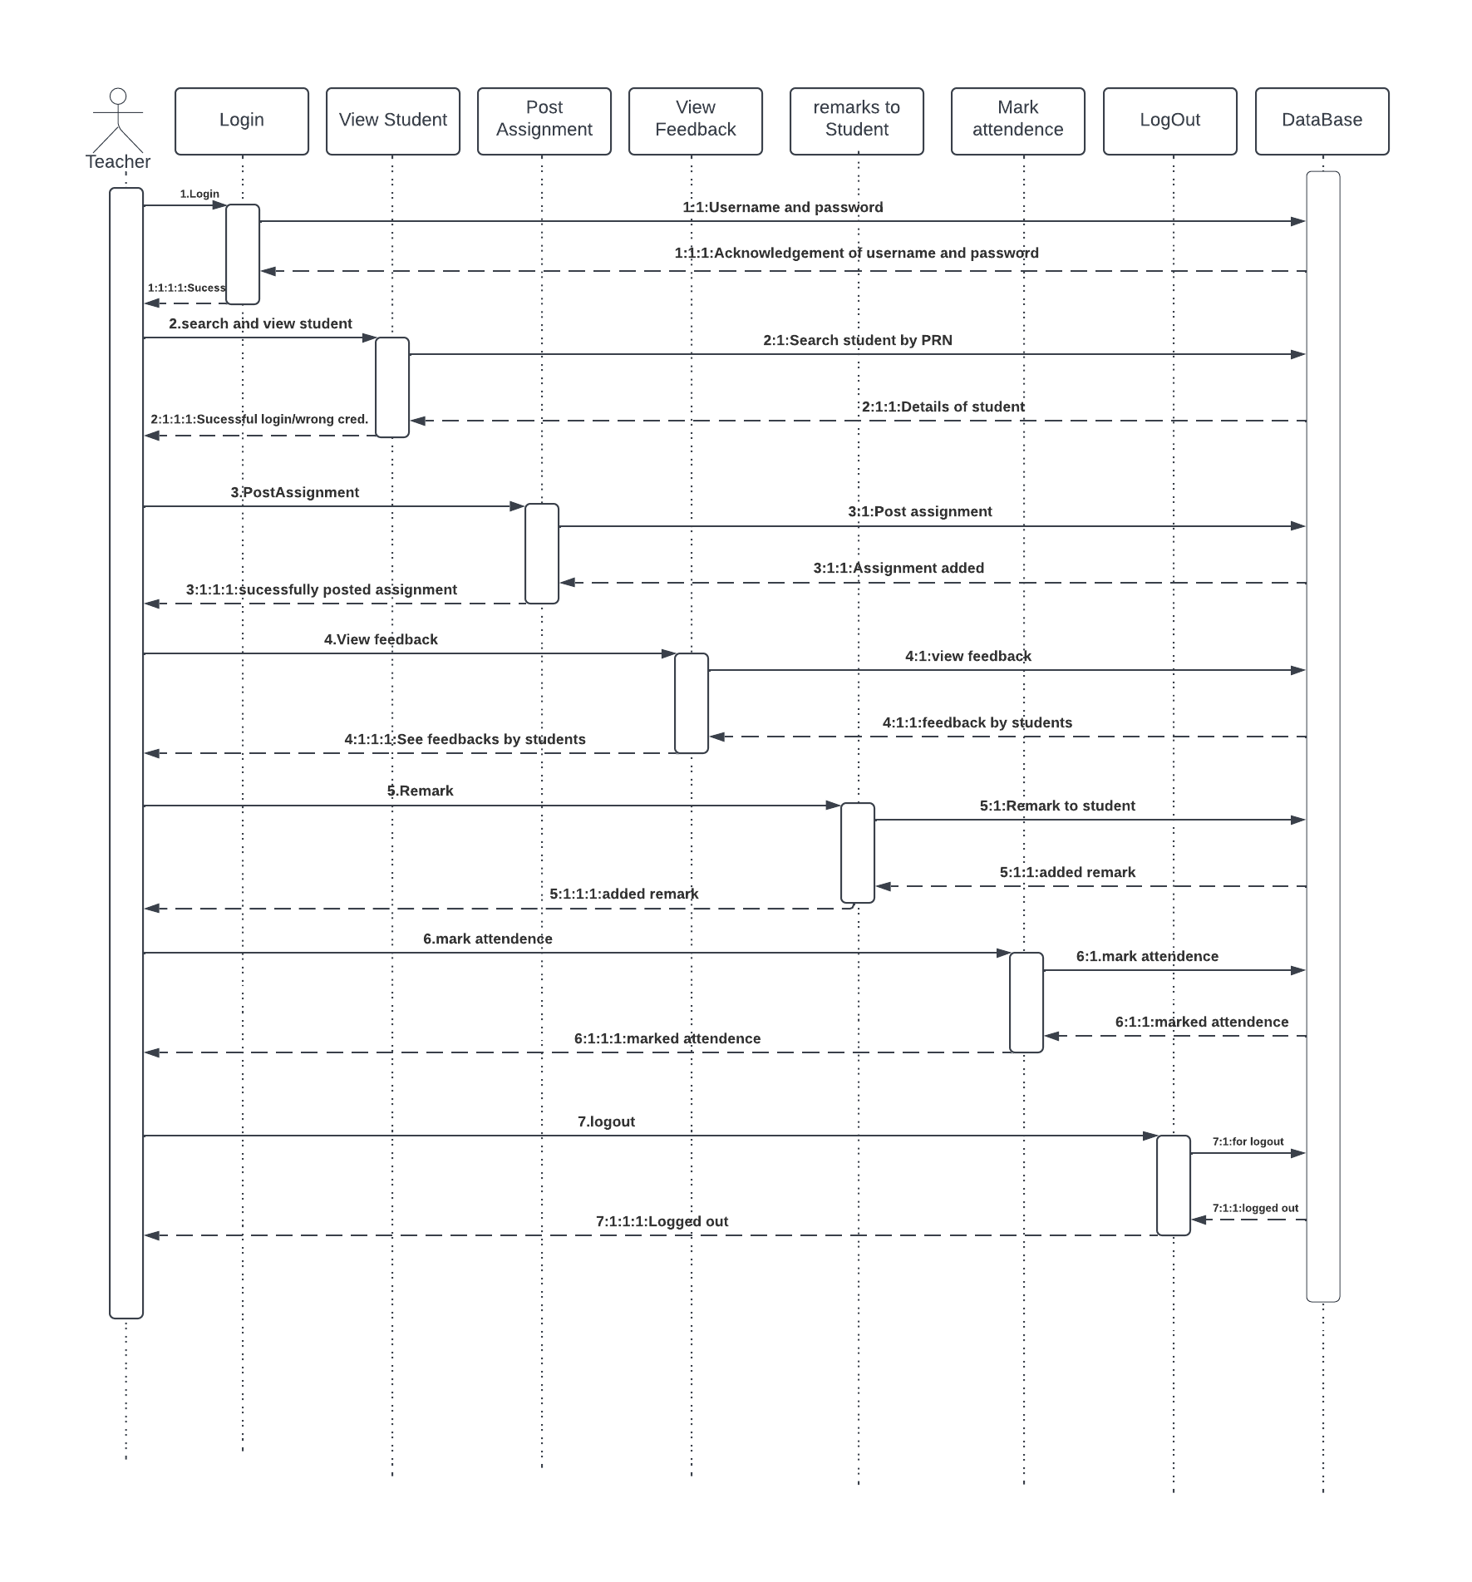

**Figure 10: Sequence Diagram for Student**

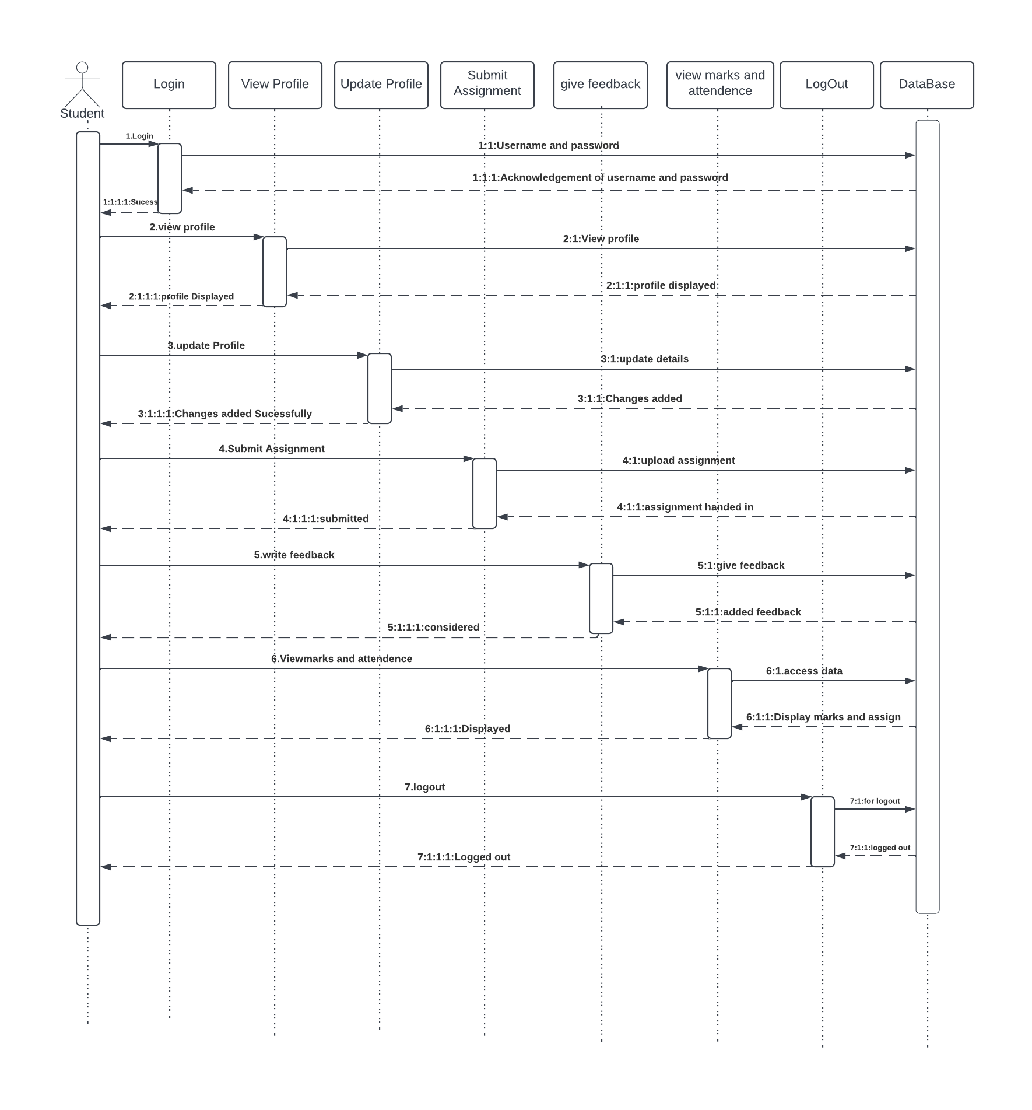

**4.5 Fig 11: Class Diagram**

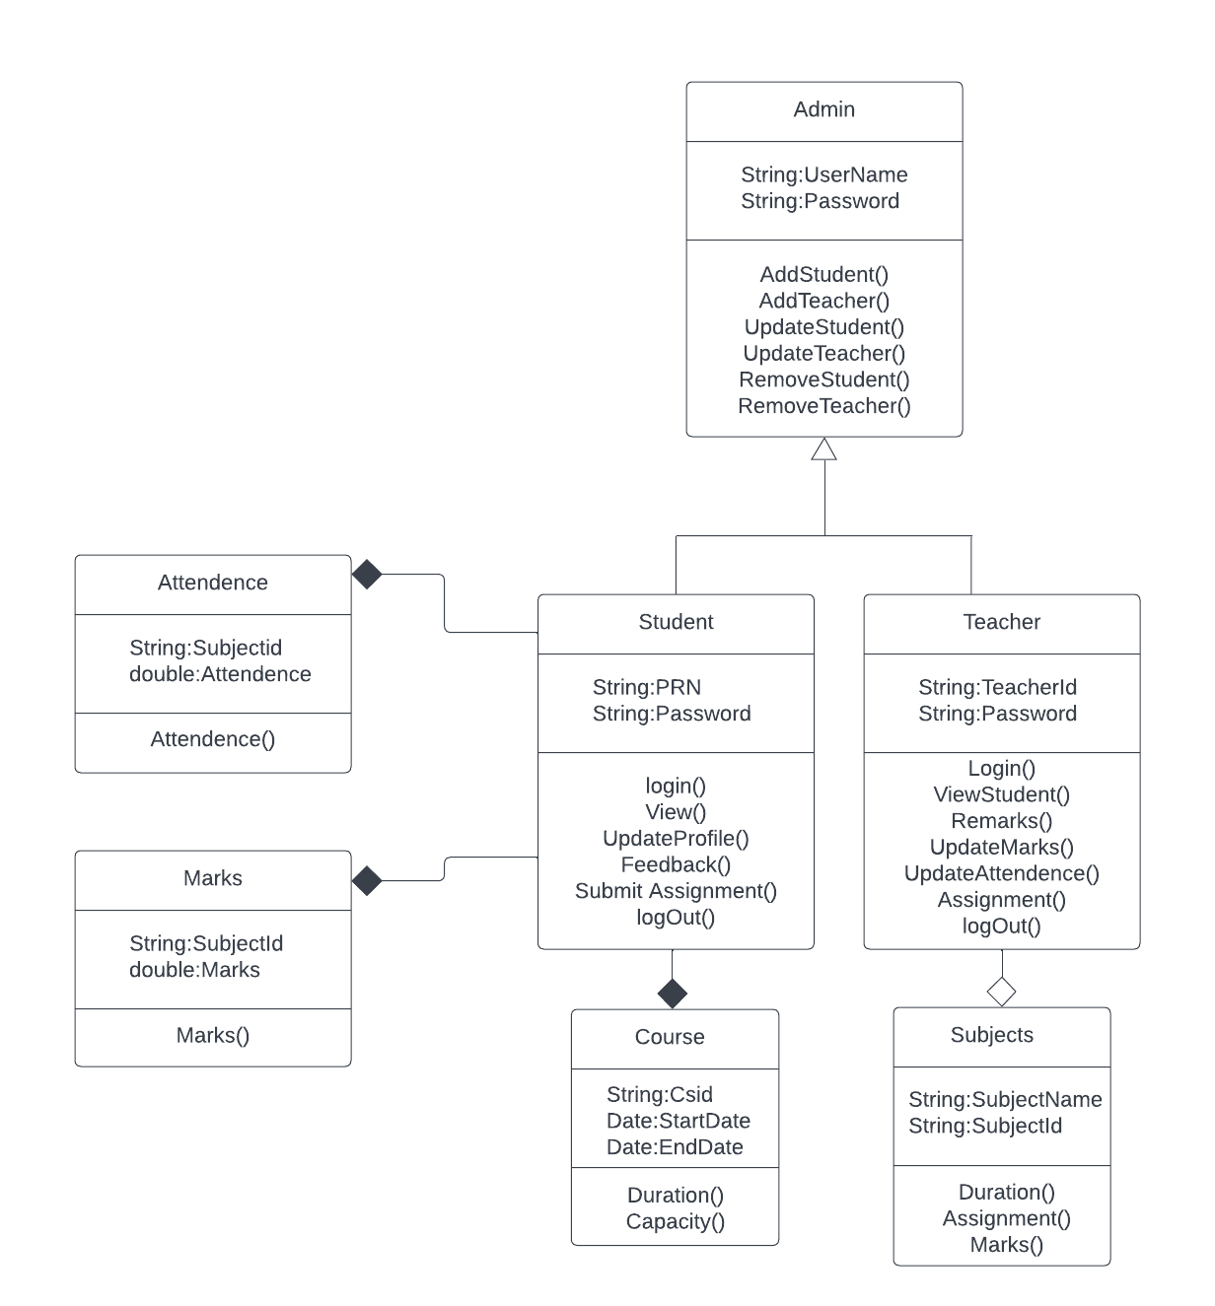

**4.6 Data Flow Diagram**

**Fig 12: Zero Level DFD**

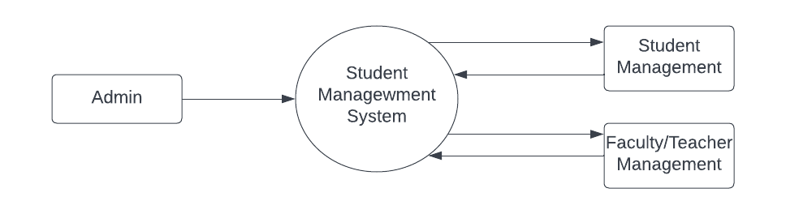

**Fig 13: Level One DFD**

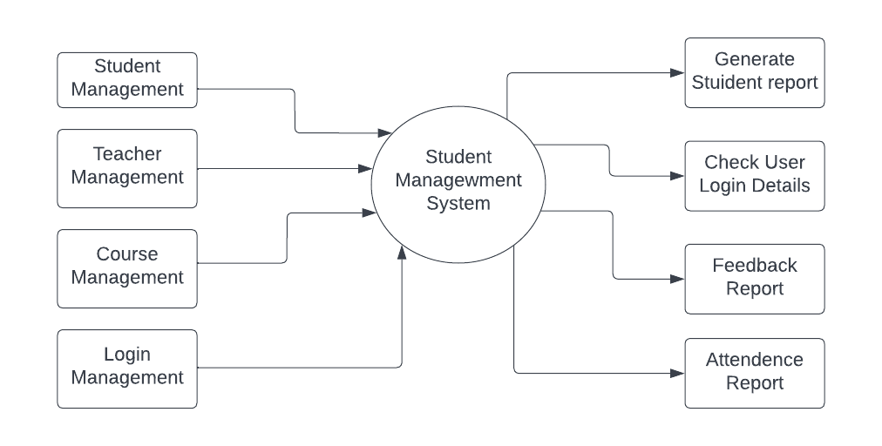

**Fig 14: Level Two DFD**

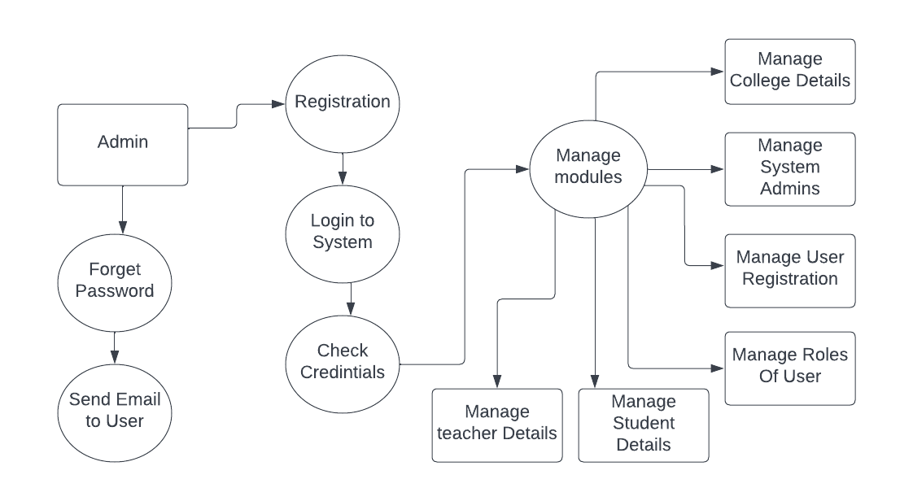

**5.DATABASE DESIGN**

The data in the system has to be stored and retrieved from database. Designing the database is part of system design. Data elements and data structures to be stored have been identified at analysis stage. They are structured and put together to design the data storage and retrieval system.

A database is a collection of interrelated data stored with minimum redundancy to serve many users quickly and efficiently. The general objective is to make database access easy, quick, inexpensive and flexible for the user. Relationships are established between the data items and unnecessary data items are removed. Normalization is done to get an internal consistency of data and to have minimum redundancy and maximum stability. This ensures minimizing data storage required, minimizing chances of data inconsistencies and optimizing for updates. The MS Access database has been chosen for developing the relevant databases.

**Admin:**

|  |  |
| --- | --- |
| **Table Name** | Admin_tbl |
| **Description** | This table is store information about Admin |
| **Primary Key** | id |
| **Foreign Key** | - |

|  |  |  |  |  |
| --- | --- | --- | --- | --- |
| **Sr. No** | **Field Name** | **Data type(Size)** | **Constraints** | **Description** |
|  |  |  |  |  |
| 1 | id (Primary) | Varchar(255) | Primary Key | It is to store Admin id |
|  |  |  |  |  |
| 2 | FirstName | varchar(20) | Not Null | It is store admin first name |
|  |  |  |  |  |
| 3 | LastName | varchar(20) | Not Null | It is store admin last name |
| 4 | AdhaarCard | varchar(12) | Not Null, Unique | It is to store admin adhaar card number |
| 5 | Password | varchar(20) | Not Null | It is store the password of Admin |
|  |  |  |  |  |
| 6 | Mobile Number | char(11) | NotNull | It is store the mobile number |
| 7 | Email | Varchar(100) | NotNull,  Uniqueue | It is store the email |
|  |  |  |  |  |

**Student Registration:**

|  |  |
| --- | --- |
| **Table Name** | students_tbl |
|  |  |
| **Description** | This table is provide the information about Student registration |
|  |  |
| **Primary Key** | Enrollment Number(PRN)/id |
|  |  |
| **Foreign Key** | Course_id,batch_id |
|  |  |

|  |  |  |  |  |
| --- | --- | --- | --- | --- |
| **Sr.** | **Field Name** | **Data type(Size)** | **Constraints** | **Description** |
| **No** |  |  |  |  |
|  |  |  |  |  |
| 1 | PRNid (Primary) | Varchar(100) | Primary Key | It is store Student PRN Number |
|  |  |  |  |  |
| 2 | FirstName | varchar(120) | Not Null | It is store Student First Name |
|  |  |  |  |  |
| 3 | LastName | varchar(120) | Not Null | It is store Student Last Name |
| 4 | Adhaar Card | char(12) | Not Null | It is store Adhaar Card number of student |

|  |  |  |  |  |
| --- | --- | --- | --- | --- |
| 5 | Password | Varchar(20) | Not Null | It is store Password |
| 6 | Mobile Number | Varchar(10) | Not Null | It is store mobile number of student |
| 7 | Email Id | Varchar(50) | Not Null | It is store email address of Student |
| 8 | Course_id | Varchar(255) | Foreign key | It is store course in which student is enrolled |
| 9 | Batch_id | int | Foreign key | It stores batch of the student |

**Teacher Registration:**

|  |  |
| --- | --- |
| **Table Name** | teachers_tbl |
|  |  |
| **Description** | This table is provide the information about teacher registration |
|  |  |
| **Primary Key** | registrationID |
|  |  |
| **Foreign Key** | Subject_id |
|  |  |

|  |  |  |  |  |
| --- | --- | --- | --- | --- |
| **Sr.** | **Field Name** | **Data type(Size)** | **Constraints** | **Description** |
| **No** |  |  |  |  |
|  |  |  |  |  |
| 1 | registrationID(Primary) | Varchar(255) | Primary Key | It is store Teacher ID |
|  |  |  |  |  |
| 2 | FirstName | varchar(120) | Null | It is store Teacher First Name |
|  |  |  |  |  |
| 3 | LastName | varchar(120) | Null | It is store Teacher Last Name |
| 4 | Adhaar Card | char(12) | Null | It is store Adhaar Card number of teacher |
| 5 | Password | varchar(100) | Null | It is store Password |
| 6 | Mobile Number | char(11) | Null | It is store mobile number of teacher |
| 7 | EmailId | varchar(100) | Null | It is store email address of teacher |
|  |  |  |  |  |
| 8 | Subject_id | varchar(100) | Foreign key | It is store id of subject teacher is teaching |

**Subject :**

|  |  |
| --- | --- |
| **Table Name** | subject_tbl |
|  |  |
| **Description** | This table is to provide the information about subjects |
|  |  |
| **Primary Key** | ID |
|  |  |

|  |  |  |  |  |
| --- | --- | --- | --- | --- |
| **Sr.No** | **Field Name** | **Data type(Size)** | **Constraints** | **Description** |
| 1 | ID(Primary) | Varchar(100) | Primary Key | It is store subject ID |
| 2 | Teacher_id | varchar(120) | Foreign Key  teacher_tbl  (registrationID) | It is store Teacher teaching the subject |
| 3 | Duration | int | Not null | It is store duration of subject |
| 4 | Course_id | Varcher(255) | Foreign key | It stores id of the course |

**Attendance:**

|  |  |
| --- | --- |
| **Table Name** | attendance_tbl |
|  |  |
| **Description** | This table is to provide the information about attendance of students per subjects |
|  |  |
| **Primary Key** | id |
|  |  |
| **Foreign Key** | Student_pnrid,subject_id |
|  |  |

|  |  |  |  |  |
| --- | --- | --- | --- | --- |
| **Sr.** | **Field Name** | **Data type(Size)** | **Constraints** | **Description** |
| **No** |  |  |  |  |
|  |  |  |  |  |
| 1 | id | varchar | Primary key | It stores id of attendance |
|  |  |  |  |  |
| 2 | attendance | Int | Not null | It is store attendance of student |
|  |  |  |  |  |
| 3 | Subject_id | Varchar(255) | Foreign key | It is store id of the subject |
| 4 | PRN(id) | Varchar(100) | Foreign Key  student_tbl  (PRN) | It is store student PRN number |

**Feedback Table:**

|  |  |
| --- | --- |
| **Table Name** | Feedback_tbl |
|  |  |
| **Description** | This table store information about feedback |
|  |  |
| **Primary Key** | F_Id |
|  |  |
| **Foreign Key** | Batch_id,teacher_id |
|  |  |

|  |  |  |  |  |
| --- | --- | --- | --- | --- |
| **Sr. No** | **Field Name** | **Data type(Size)** | **Constraints** | **Description** |
|  |  |  |  |  |
| 1 | id (Primary) | int(11) | Primary Key | It is store feedback id |
|  |  |  |  |  |
| 2 | feedback | varchar(100) | Not null | It is store feedback |
|  |  |  |  |  |
| 3 | Batch_id | int | Foreign key | It stores batch id |
|  |  |  |  |  |
| 4 | Teacher_id | Varchar(255) | Foreign key | It stores teacher id |
|  |  |  |  |  |

**Course Table:**

|  |  |
| --- | --- |
| **Table Name** | Course_tbl |
|  |  |
| **Description** | This table store information about course |
|  |  |
| **Primary Key** | Id |
|  |  |
| **Foreign Key** | - |
|  |  |

|  |  |  |  |  |
| --- | --- | --- | --- | --- |
| **Sr. No** | **Field Name** | **Data type(Size)** | **Constraints** | **Description** |
|  |  |  |  |  |
| 1 | id (Primary) | int(11) | Primary Key | It is store course id |
|  |  |  |  |  |
| 2 | duration | int | Not null | It is duration of course |
|  |  |  |  |  |
| 3 | fees | double | Not null | It stores fees details of course |
|  |  |  |  |  |

**Batch Table:**

|  |  |
| --- | --- |
| **Table Name** | Batch_tbl |
|  |  |
| **Description** | This table store information about batch |
|  |  |
| **Primary Key** | id |
|  |  |
| **Foreign Key** |  |
|  |  |

|  |  |  |  |  |
| --- | --- | --- | --- | --- |
| **Sr. No** | **Field Name** | **Data type(Size)** | **Constraints** | **Description** |
|  |  |  |  |  |
| 1 | id (Primary) | int(11) | Primary Key | It is store batch id |
|  |  |  |  |  |
| 2 | name | varchar(20) | Not null | It is store name of the batch |
|  |  |  |  |  |
| 3 | End_date | Date | Not null | It stores end date of batch |
|  |  |  |  |  |
| 4 | Start_date | date | Not null | It stores start date of batch |
|  |  |  |  |  |

**Mark Table:**

|  |  |
| --- | --- |
| **Table Name** | mark |
|  |  |
| **Description** | This table store information about marks |
|  |  |
| **Primary Key** | Id |
|  |  |
| **Foreign Key** | Student_pnr,subject_id |
|  |  |

|  |  |  |  |  |
| --- | --- | --- | --- | --- |
| **Sr. No** | **Field Name** | **Data type(Size)** | **Constraints** | **Description** |
|  |  |  |  |  |
| 1 | id (Primary) | int(11) | Primary Key | It is store mark id |
|  |  |  |  |  |
| 2 | marks | int | Not null | It is store marks |
|  |  |  |  |  |
| 3 | subject_id | Varchar(255) | Foreign key | It stores subject id |
|  |  |  |  |  |
| 4 | Student_pnr | Varchar(255) | Foreign key | It stores student id |
|  |  |  |  |  |

**6.Conclusion**

Online Student Management System can be acted as the key medium between the three layers of Institute such as Admin, Teacher and the Student as the prime user .

This system will help institute to organize its data as per the batch.

The application was designed in such a way that future modifications can be done easily.

The following conclusions can be deduced from the development of the project.

¬ Automation of the entire system improves the efficiency

¬ It provides a friendly graphical user interface which proves to be better when compared to the existing system.

¬ It gives appropriate access to the authorized users depending on their permissions.

¬ Updating of information becomes so easier.

¬ The System has adequate scope for modification in future if it is necessary.

¬ Provides convenience to the students, faculties and management in order to communicate .

**6.1 Future Scope**

We can use Socket.io to add a chat system for Student and Teacher. Student can then ask their doubts to Teachers and they can also talk with other students to know how they learnt a particular skill, etc.

We can give the option of timetable where the Admin can create the timetable for each semester.

The validation can be improved furthermore. We have tried to keep the validation logic correct and there might be few things missing.

**7.Refrences**

The following books were referred during the analysis and execution phase of the project

1. Black book by DT Editorial Services

(Coverscss3,Javascript,xml,xhtml,Php,and Jquery)

2. MYSQL by Paul Dubois

WEBSITES: www.google.com

.